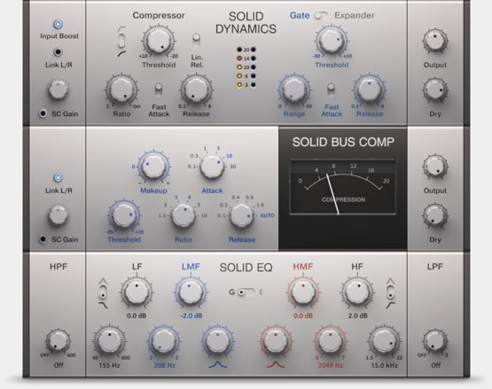
Individually, these effects provide powerful, easy-to-apply enhancements. Together, they form a cohesive toolset for shaping and ‘exciting’ your sound.
- SOLID EQ: Two models in one, with switchable curve shapes. A precise 6-band equalizer for all kinds of jobs, from subtle shading to aggressive shaping.
- SOLID DYNAMICS: A clean, musical dynamics section, combining a stereo compressor, expander and gate in one single effects unit. Works best on single channels.
- SOLID BUS COMP: More than a bus compressor. Use it on anything – single channels, subgroups, master channel – for consistently rewarding results.

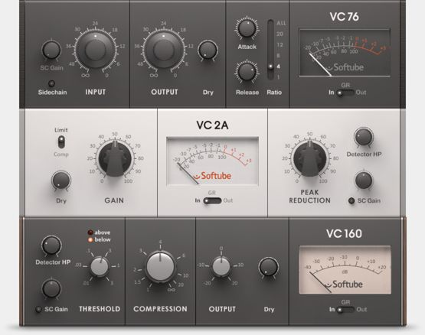
Each of the three compressors has its own unique character and specific advantages:
- VC 76: Workhorse compressor with a fast attack. Great presence, punchy, clear high end. Good for drums, vocals or stereo limiting.
- VC 2A: Smooth compressor with a silky, natural sound. Great on vocals, bass, pads and guitar.
- VC 160: Classic compressor for added attack and a subtle drive. Especially good on kickdrum, snare, bass or guitar.

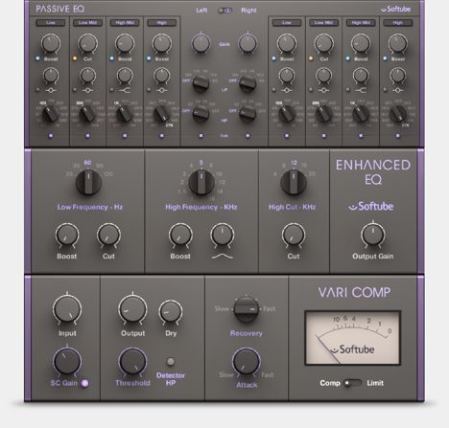
The PREMIUM TUBE SERIES bundle consists of three exceptional effects. Together, they form a professional effects suite for production, mixing and mastering.

- PASSIVE EQ: Rich and highly musical, this EQ is an all-purpose weapon for every stage of your production – from shaping individual tracks to final mastering.
- VARI COMP: A highly flexible compressor with a natural, transparent sound. Just as comfortable working on subgroups as on stereo sum.
- ENHANCED EQ: Unique yet simple to use, this EQ fattens and enhances the low end, and adds definition and clarity on the midrange.

